**ST10379626 NICHOLAS RATSELA Programming Part 2.**

**Added Features on my Part 2.**

* I Added Two New Views For Program Coordinator and Academic Programmer which are named (Claim Submitted) for Program Coordinator and (Claim Accepted) for Academic Manager.
* The Claim Submitted view for the Program Coordinator can Approve and Reject a Claim from the Lecture.
* The Claim Accepted view is for the Academic Manger where The manager can Accept Claims which were made by the Lecture and went through processing by the Program Coordinator to make sure the claim is Valid.

**User Manual.**

Welcome to the Lecture Claims Home Page.

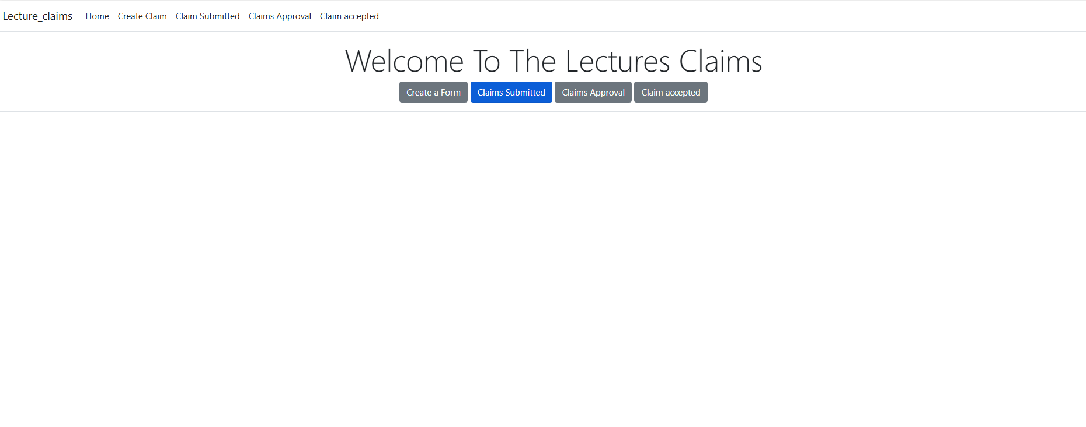

This page is designed to streamline the process of submitting and managing lecture claims efficiently. Here's a quick guide to help you navigate:

-**Navigation Bar**: At the top, you’ll see a navigation bar with the following options:

-**Home**: Returns you to this main page.

-**Create Claim**: Initiates a new claim submission.

-**Claim Submitted**: View claims you have submitted.

-**Claims Approval**: Check the approval status of your claims.

-**Claim Accepted:** View claims that have been accepted.

Main Content Area: Under the navigation bar, there's a large welcoming message: Welcome To The Lectures Claims.

**Action Buttons**: Below the welcome message, you’ll find four key buttons:

**Create a Form**: Start creating a new lecture claim form.

**Claims Submitted**: Review all your submitted claims. This is highlighted, showing it is the current active selection.

**Claims Approval**: View the status of pending claims awaiting approval.

**Claim Accepted**: View the claims that have been successfully accepted.

**Welcome to the Claim Form Page for Lecture Claims.**

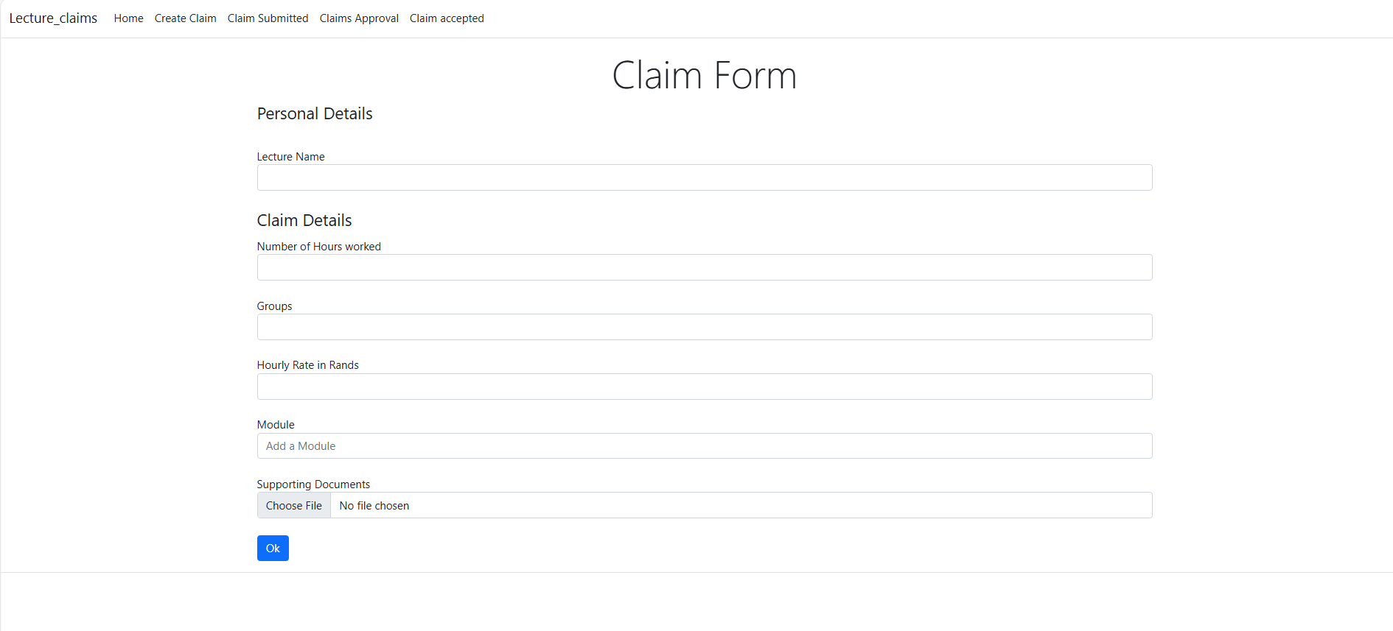

Form Fields:

**Lecture Name**: Enter your full name.

**Number of Hours Worked**: Specify the total hours you’ve worked.

**Groups**: Indicate the group or groups you lectured.

**Hourly Rate (in Rands):** Input your hourly rate.

**Module**: Choose the relevant module from the dropdown list.

**Supporting Documents**: Upload any necessary documents by clicking the file upload option.

**Submit Button:** After filling out all the details, click the Ok button to submit your claim.

**Welcome to the Claim Submitted Page for Lecture Claims.**

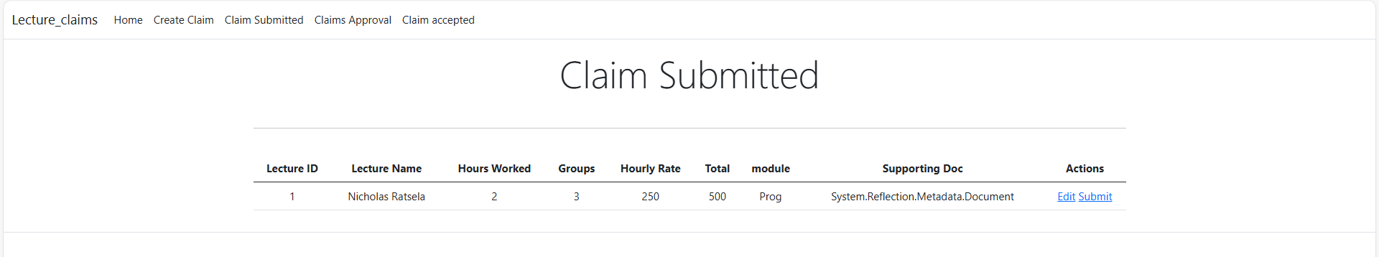

**Total Claim Amount**:

Displayed at the top, this shows the overall amount for all claims.

**Table Columns**:

**Lecture ID**: Your unique identifier as a lecturer.

**Lecture Name**: The name of the lecturer who submitted the claim.

**Hours Worked**: The total hours logged for this lecture.

**Groups**: Number of student groups involved.

**Hourly Rate**: The rate per hour in ZA Rands.

**Tota**l: The total calculated amount (Hours Worked x Hourly Rate).

**Module**: The specific module for which the claim is made.

**Supporting Doc**: Any supporting documents attached to the claim.

**Actions**: Options to edit or submit the claim.

**Action Buttons:**

**Edit:** Allows you to modify the details of your claim.

**Submit:** Finalizes your claim and sends it for approval.

**Welcome to the Claims Approval Page! Here’s how to navigate this section:**

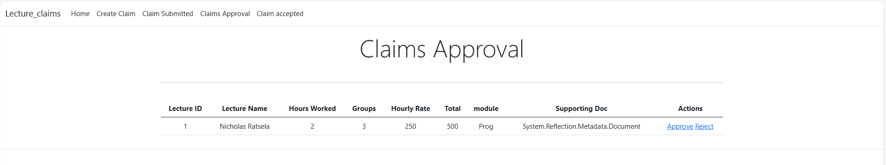

**Page Title:**

* **Claims Approval**: This is where you can review and approve submitted claims.

**Total Claim Amount:**

* Displayed at the top, it shows the overall amount for all claims needing approval.

**Table Columns:**

* **Lecture ID**: Unique identifier for each lecturer.
* **Lecture Name**: Name of the lecturer.
* **Hours Worked**: Total hours logged for the lecture.
* **Groups**: Number of student groups involved.
* **Hourly Rate**: Rate per hour in Rands.
* **Total**: Calculated amount (Hours Worked x Hourly Rate).
* **Module**: Specific module related to the claim.
* **Supporting Doc**: Any supporting documents attached to the claim.
* **Actions**: Options to approve or reject the claim.

**Action Buttons:**

* **Approve**: Approve the submitted claim.
* **Reject**: Reject the claim if it doesn't meet the required standards.

**Welcome to the Claim Accepted Page! Here’s how to navigate:**

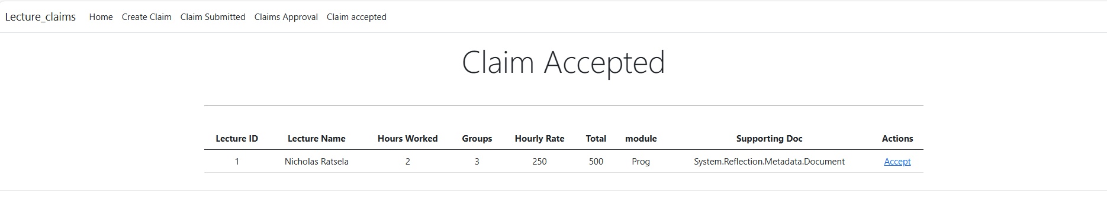

**Page Title:**

* **Claim Accepted**: This is where you can review all the lecture claims that have been accepted.

**Total Claim Amount:**

* Displayed at the top, it shows the overall amount for all accepted claims.

**Table Columns:**

* **Lecture ID**: Unique identifier for each lecture claim.
* **Lecture Name**: Name of the lecturer.
* **Hours Worked**: Total hours logged for the lecture.
* **Groups**: Number of student groups involved.
* **Hourly Rate**: Rate per hour in Rands.
* **Total**: Calculated amount (Hours Worked x Hourly Rate).
* **Module**: Specific module related to the claim.
* **Supporting Doc**: Any supporting documents attached to the claim.
* **Actions**: Option to accept the claim.

**Action Button:**

* **Accept**: Confirms and finalizes the accepted claim.